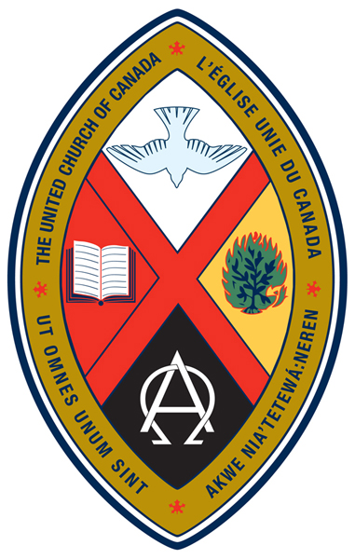
WELCOME TO
CLOVERDALE PASTORAL CHARGE
the united church of canada

Telephone: 604-574-5813
Fax: 604-574-5816

Website: www.cloverdaleunitedchurch.ca

Office E-mail: cloverdalehazelmereuc@telus.net

Cloverdale Hazelmere
17575 - 58 A Ave. Surrey 1614 - 184 St. Surrey
Worship & Sunday School - 10:30 am Worship - 8:45 am

Minister: Rev. Lori Megley-Best (lori.megley-best@telus.net)
Cloverdale Music Director: Sharon Lauzé
Hazelmere Music: Jo-Anne Rattray / Phyllis Barnson
Office Administrator: Janet Cliff
Summer Office Hours: Tuesday, Wednesday, Thursday 10am – 2pm

Following Worship, please join us for conversation and refreshments.

June 28, 2015

This week at Cloverdale Pastoral Charge:

Today: 5th after Pentecost – Joint HUC & CUC Worship 10:30am
MUSIC Sunday
(CUC) Celebration Box
Tuesday: ZUMBA (CUC) – 8am
Wednesday: Happy Canada Day!
Next Sunday: 6th after Pentecost – Worship Leader: Jane Harding
(HUC) Food Bank Sunday



Today is Music Sunday

with cake and strawberries
after a music-filled worship service.

Left Behind at Picnic Sunday …. A turquoise hoodie and a blanket. Please call the office to claim.

Please note:
Rev. Lori will be away June 28th until August 9th

Summer Office Hours:
Tuesday, Wednesday, Thursday 10am – 2pm

Scripture Readings for July 5th ~ 6th after Pentecost
2 Samuel 5:1-5, 9-10 Psalm 48
2 Corinthians 12:7-10 Mark 6:1-13

At Cloverdale this morning:
Coffee: Choir Members
Greeters / Ushers: Choir Members
Projectionist: Evan Sherwood
Sign-Up sheet is available at Coffee Hour or please see Marjorie Saunders.

Down to the River to Pray
Join the Presbytery Vision Team this summer in a prayer circle each Tuesday evening 7pm through July and August. We’ll meet down at the Fraser River in Ft Langley – at the Heritage Area near Derby Reach on Allard Crescent. As we embrace the rhythm and spirit of summer we gather for a simple time of prayer together. Gather with friends, enjoy the outdoors, refresh and renew your spirit. Invite friends and folks from your congregation. Rain or shine, we look forward to seeing you
Schedule:
July 7, 14, 21, 28 - August 4, 11, 18, 25 - September 1

Derby Reach Regional Park is located in northern Langley, near Fort Langley, and along the shores of the Fraser River. To get to the park from Vancouver, drive east towards Highway #1 and merge with the highway heading eastbound. Continue along the highway taking Exit #58 200th Street North. After turning off the highway, go left, crossing over the highway and continue along 200th street to 96th Avenue. Turn right onto 96th Avenue and continue for a short distance and make a left onto 208th Street. Continue driving along 208th Street to Allard Crescent and make a right. Drive along Allard Crescent for about 2km and watch for park signs, making a left into the park and the large parking area.
To drive to the Historic Area where the Houston Trail starts, continue driving straight along Allard Crescent for another 2km and watch for a gravel parking lot on your right.

MUSIC SUNDAY


In 1943, when Mrs. Jean Taylor was a member of the Choir, she presented the idea of holding a Special Music Service on a Sunday in June before the Choir recessed for the summer. Her suggestion was approved by everyone, with the result that the eventual performance was so well received, it became an annual event. Thus began the tradition of “Music Sunday”.

In 1946, when Mr. Harold Wooster, the former Choir Director retired, Mrs. Taylor took on the position. She continued to lead the Choir until her retirement in 1966. Her daughter, Mrs. Shirley Barker, took her mother’s place and directed the Choir for many years until her untimely death in 1978. Mrs. Taylor died in April 1985.

After Shirley’s death, David Proznick became Choir Director, continuing for ten years. He was followed by Steven Johnston who also directed for ten years. When Steven left in 1998, Tim Bailey took over and led our choir until the end of 2007. In 2008, Sharon Lauzé became our Choir Director. Because these leaders faithfully carried on the tradition of Music Sunday, we are celebrating the 72nd Anniversary of this event on Sunday, June 28, 2015.

Over the years, we have enjoyed organ music from Beth (Leullier) Scott, Pat Patterson, Grace Gauthier and Tim Bailey. Dianne Nichols has now taken over this role when needed.

Some years ago, the Choir started a tradition of their own by serving Strawberry Shortcake after the service, during coffee hour. This was their way of saying ‘thank you’ to the Congregation for their support over the years.

.....original information on Music Sunday
Compiled by Dora Rogers ~ May, 2002
Updated June 2014

Midsummer M&S Event - Meet the United Church of Canada's Overseas Personnel and find out how our M&S has been really working as God's Gift in the world.


Tuesday July 28th, 2015
Noon - 2:30 pm
United Churches of Langley
Sharon Chapel
21562 Old Yale Road, 604.530.2929
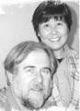
Our guests, UCC Overseas personnel Robert and Keiko Witmer, were commissioned by London Conference and have been serving the United Church of Christ in Japan since 1969. This will be an opportunity to find out how our M&S has been really working as God's Gift in the world.

Please bring bag lunch. There will be some appetizer SUSHI, fruit and tea. For more information please call Masako at 604.882.5983.



