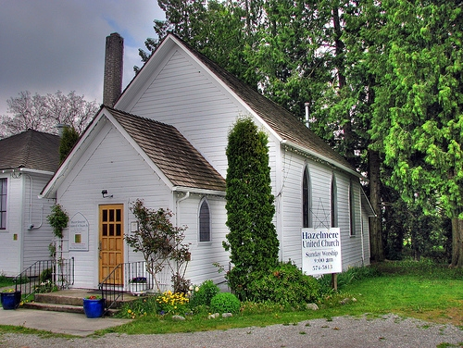
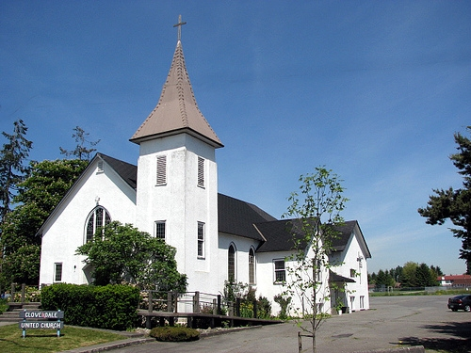
March  2015 |  | Cloverdale Pastoral Charge The United Church of Canada  17575 - 58A Avenue Surrey, B.C. V3S 1N1 / Telephone: 604-574-5813 / Fax: 604-574-5816  E-mail: cloverdalehazelmereuc@telus.net / Website: cloverdaleunitedchurch.ca  Worship & Sunday School: Hazelmere 8:45 a.m. / Cloverdale 10:30 a.m.  Minister: Rev. Lori Megley-Best / Email lori_megley-best@telus.net
Sunday | Monday | Tuesday | Wednesday | Thursday | Friday | Saturday
1 2nd Sunday in Lent  GENEROSITY  (HUC) Food Bank Sunday  Living Stones Church 1-5pm | 2   | 3  Lenten Study  1-2:30 or 6:30-8pm  OA 7:30// AA 7pm  Brownies 6-8pm |   4 Sunshine Unit  7:30pm at  JoAnn Brown’s  AA- 12noon / AA 7-9pm / AA 7-8 | 5    CUC Choir 730  OA – 7:30pm | 6 World Day of Prayer  St. Bernadette’s RC - 1pm    AA 12-1 / AA – 8-9pm | 7
8 3rd Sunday in Lent  OBEDIENCE  Worship at Zion Park - 3pm  Gift Card Orders Due  Daylight    Saving  Time Begins  Living Stones Church 1-5pm | 9 HUC Council – 7pm  AA-12 noon / NA 7-830 | 10  Lenten Study  1-2:30 or 6:30-8pm  HUC Council – 10am  OA 7:30// AA 7pm | 11  AA- 12noon / AA 7-9pm / AA 7-8 | 12  CUC Choir 730pm  OA – 7:30pm | 13  AA 12-1 / AA – 8-9pm | 14
15 4th Sunday in Lent  REPENTENANCE  Living Stones Church 1-5pm | 16  AA-12 noon / NA 7-830 | 17   Lenten Study  1-2:30 or 6:30-8pm  UCW Spring Rally  Colebrook UC – 9:30am  OA 7:30// AA 7pm  Querin Dance 330-830pm |   18  Alpha Unit – 1pm (lounge)  AA- 12noon / AA 7-9pm / AA 7-8 | 19  CUC Choir 730pm  OA – 7:30pm |   20  AA 12-1 / AA – 8-9pm | 21  Upper Hall Reserved  11am – 2pm
22 5th Sunday in Lent  FORGIVENESS  (CUC) Congregational Mtg  To accept Ministry Profile Report from Search Committee  Living Stones Church 1-5pm | 23  AA-12 noon / NA 7-830  Pathfinders 6-830pm | 24  Lenten Study  1-2:30 or 6:30-8pm  OA 7:30// AA 7pm  Brownies 6-8pm | 25  AA- 12noon / AA 7-9pm / AA 7-8 | 26  CUC Choir 730pm  OA – 7:30pm  OA-730pm  OA-730pm | 27  AA 12-1 / AA – 8-9pm  AA-830pm | 28  
  29 Palm Sunday  (CUC) Celebration Box  Living Stones Church 1-5pm | 30  AA-12 noon / NA 7-830  Pathfinders 6-830pm |   31  CUC Council – 7pm  OA 7:30// AA 7pm  Brownies 6-8pm

