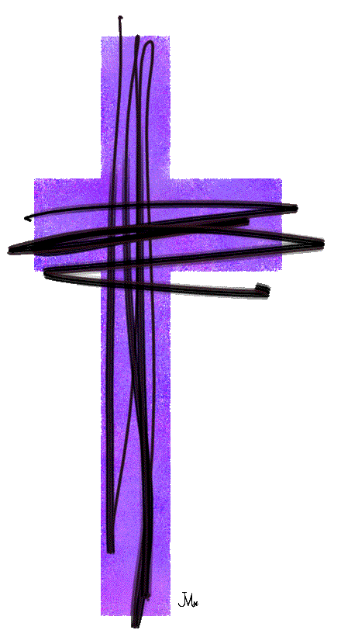
“Longing For Home”

Our Lenten Study

The First 4 Tuesdays in March
1:00-2:30pm OR 6:30-8pm
In Cloverdale’s Sanctuary

Join us to read scripture, pray, share our faith questions and engage in spiritual practice together.
Via video recording we will welcome our moderator
Gary Paterson, as he reflects on each of the gospel readings for Lent.

Weekly topics and scripture readings:

- March 3- What does suffering have to do with my faith? Mark 8:31-38
- March 10- What is the nature of God's judgment? John 2:13-22
- March 17- What is eternal life? John 3:14-21
- March 24- Losing our life? John 12:20-33

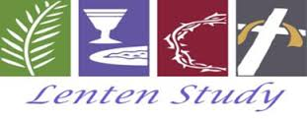

Pursued by God - the pressure,
the pain, the promise.
Throughout Lent we will be exploring the scripture texts of covenant. Throughout history God has entered into a covenant relationship with us.
And God will not let us get away from that. What does our life of faith look like,
how do we be church, when we are being pursued by a love that will not let us go?

Each week we will look at a covenant text and consider a spiritual practice that enables us to say Yes to the unconditional love that God offers.
Feb. 22 Genesis 9:8-17
Gratitude
March 1 Genesis 17:1-7,15-16
Generosity
March 8 Exodus 20:1-17
Obedience
March 15 Numbers 21:4-9
Repentance

March 22. Jeremiah 31:31-34
Forgiveness

WELCOME TO CLOVERDALE PASTORAL CHARGE
the united church of canada

Telephone: 604-574-5813 / Fax: 604-574-5816

Website: www.cloverdaleunitedchurch.ca

Office E-mail: cloverdalehazelmereuc@telus.net
Cloverdale Hazelmere
17575 - 58 A Ave. Surrey 1614 - 184 St. Surrey
Worship & Sunday School - 10:30 am Worship - 8:45 am
Minister: Rev. Lori Megley-Best (lori.megley-best@telus.net)
Cloverdale Music Director: Sharon Lauzé
Hazelmere Music: Jo-Anne Rattray / Phyllis Barnson
Office Administrator: Janet Cliff
Office Hours: Tuesday, Wednesday, Thursday, Friday 10am – 2pm

Following Worship, please join us for conversation and refreshments

February 22, 2015

This week at Cloverdale Pastoral Charge:
Today: First Sunday in Lent – Communion Sunday
(CUC) Celebration Box
Readers: Betty Pederson (H) Victoria Watters (C)
Tuesday: CUC Council – 7pm
Thursday: Search Committee Meeting – 6pm
(CUC) Choir Rehearsal – 7pm

Next Sunday: 2nd Sunday in Lent
(HUC) Food Bank Sunday

”Longing For Home”
Our Lenten Study
The First 4 Tuesdays in March
1:00-2:30 OR 6:30-8PM In the Sanctuary
Join us to read scripture, pray, share our faith questions
and engage in spiritual practice together.
Via video recording we will welcome our moderator Gary Paterson, as he reflects on each of the gospel readings for Lent.

Weekly topics and scripture readings:
- March 3- What does suffering have to do with my faith? Mark 8:31-38
- March 10- What is the nature of God's judgment? John 2:13-22
- March 17- What is eternal life? John 3:14-21
- March 24- Losing our life? John 12:20-33

Sign up on Sunday morning or call the church office.
Week 1
Spiritual Practice
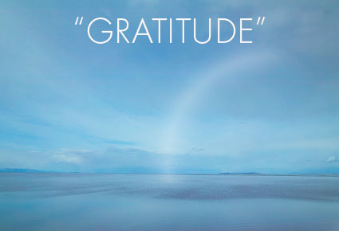

Keep a blessing journal.
Count your blessings every single day.
Write them down.
Record your blessings
even if you don't feel grateful.

Prayer phrase
To thee, O God, I life up my soul
Psalm 25:1

WE CARE BAGS -- We have made 31 "we care bags" and they are full of goodies. It's so much more than we were expecting! Some will be left at the church for those who drop in looking for help, and arrangements are being made to take the rest to the homeless. Thank you all for your generosity in making this outreadh happen.

Foster Parents Plan – Sponsorship update is posted. The report gives information on the progress of Miguel Esquivel and his family in Paraguay.


Faith, justice and ethical living …
February issue is posted.
Cover Story: The Unlikely Ascent of Kathleen Wynne – Ontario’s first female premier has surmounted barriers all her life.
But she’s never strayed far from her United Church roots.

Scripture Readings for March 1st ~ Second Sunday in Lent
Genesis 17:1-7, 15-16 Psalm 22:23-31
Romans 4:13-25 Mark 8:31-38

At Cloverdale this morning:
Coffee: Sharon McBain & Marjorie Saunders
Greeters / Ushers: Sydney MacPherson & Muriel Grossman
Projectionist: Geoff Grace
Sign-Up sheet is available at Coffee Hour or please see Marjorie Saunders


Update on Donalda Brown - Donalda has moved back to Langley Memorial Hospital to the PATH unit in the south tower again on the third floor. They are really going to try to get her prepared for going home. Please keep Donalda in your thoughts & prayers.

Vespers in the Valley Sunday, February 8th at 4 p.m. at Northwood United, featuring Glenda Rae, Brett Wade & Miles Black. Come relax, take a breath, listen to the Lower Mainland’s finest jazz …a time of vibrant, joyful, soulful, and reflective worship.. By voluntary donation. March 8th:Anita Eccelston / March 22nd Leora Cashe & Nancy Newman.

NEW BANNER … Our Tapestry of Love.
In 2012 on the occasion of the 50th anniversary of the United Church Women, this banner was designed and created by Kathleen Brown of Garden City United Church in Victoria. It is on loan to us for display until mid-March.

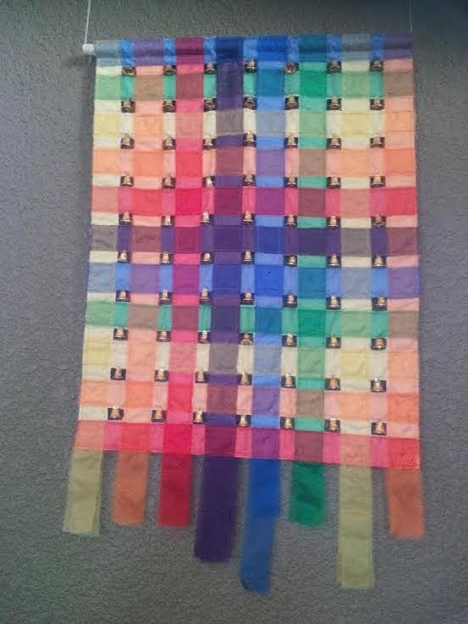
The story behind the design …. As Christians and as United Church Women, we are woven into the fabric of the body of Christ, bound together in the woof and weft. The dark colours call us to remember the shadowy places where God’s light was hidden. The bright colours remind us of our joys and celebrations.

God calls us to weave patterns of beauty and wholeness in partnership with others. We are called to support and strengthen each other as we interweave our ideas and gifts, working as the hands and feet of God in the world. We are called to mend, to darn, to work and to create a new vision and a new hope for the UCW and all God’s people.

The woven cross appears to be open at both ends. They are not bound or finished. So it is with our tapestry of life. We are open to the Spirit; our wok is not yet complete. We continue to Witness, Study, Fellowship and Serve.

WORLD DAY OF PRAYER is a global, ecumenical movement of Christian women joined together to observe a common day of prayer each year on the first Friday of March. The motto of "Informed Prayer & Prayerful Action " signifies that prayer and action are inseparable.

Friday, March 6, 2015 ~ 1pm
St. Bernadette’s Roman Catholic Church
6543 – 132 Street, Surrey
2015 Theme: Bahamas 2015
Jesus said to them,
"Do you know what I have done to you?"

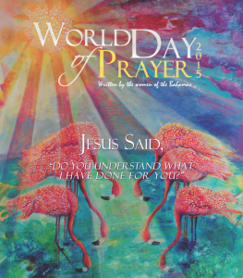
The Bahamas is a place beauty. The beautiful colors gifted by nature are reflected in the worship service and the artwork. The islands give voice to the people of The Bahamas who invite the world to "come and be washed in God's ever-flowing ocean of grace: to bask in the iridescent light of Christ's love, and to be embraced by [God's] Holy Spirit with the cooling trade-winds of transformation."

Radical love is the theme that weaves together all the components of the worship resources. They eloquently tell us that Jesus is God's presence of radical love in the world. Following Jesus' example of washing his disciple's feet, we are asked to continue the gesture of love in The Bahamas and in our own communities. That is how the spiral of informed prayer and prayerful action moves around the globe.

As we listen to our Bahamian sisters throughout the worship service, we realize that transformation is seen when a teen mother does not feel alone as she finds support to continue her education and to raise her child, when a breast cancer survivor or people living with HIV and AIDS find strength to live out their journey, and when the chains of oppression and enslavement are broken. Also, let's not forget the call for responsible stewardship of God's creation shared by all; whether it is those who step in the pink sand or swim in turquoise water of the archipelago, or those who enjoy whatever natural beauty has been gifted by God to your corner of the world.

Fraser Presbyterial UCW Spring Rally & AGM
Colebrook United 5441 – 125A Street, Surrey
Tuesday, March 17, 2015 from 9:30 am - 2:30 pm
Theme: “End Child Poverty”
Keynote Speaker: Trish Garner
Community Organizer for the BC Poverty Reduction Coalition



BC Conference UCW Women’s Ministry Network
April 28 to 30, 2015
At Bethany-Newton United Church
14853 60 Avenue, Surrey
Theme: What Kind of House will You Build? … from Isaiah 66:1
Registration forms available from UCW or Church office.
Questions: Email ljborys@gmail.com
Or Registrar jbose@telus.net

