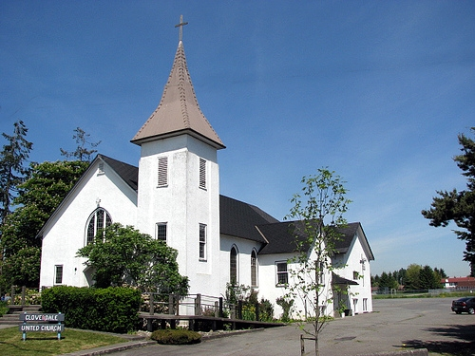  February  2015 |  | 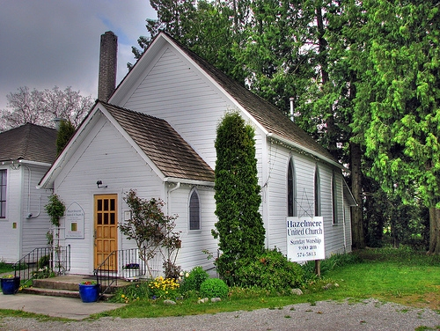  Cloverdale Pastoral Charge The United Church of Canada  17575 - 58A Avenue Surrey, B.C. V3S 1N1 / Telephone: 604-574-5813 / Fax: 604-574-5816  E-mail: cloverdalehazelmereuc@telus.net / Website: cloverdaleunitedchurch.ca  Worship & Sunday School: Hazelmere 8:45 a.m. / Cloverdale 10:30 a.m.  Minister: Rev. Lori Megley-Best / E-mail: lori.megley-best@telus.net
Sunday | Monday | Tuesday | Wednesday | Thursday | Friday | Saturday
1 4th after Epiphany  (HUC) Food Bank Sunday  Gift Card Orders Due  Living Stones Church 1-5pm | 2  AA-12 noon / NA 7-830  Pathfinders 6-830pm | 3    Friendship Unit ~ 1:30pm  at Muriel Sowerby’s  God & the Movies  “Imitation Game” 6:45pm  Rialto Theatre, White Rock  OA 7:30// AA 7pm  Brownies 6-8pm  OA 7:30// AA 7pm  Brownies 6-8pm |   4  Sunshine  Unit – 7:30 pm  at Heather Becker’s  AA- 12noon / AA 7-9pm / AA 7-8 | 5 E-Book Training  9am at Cloverdale    CUC Choir  730pm  OA – 7:30pm | 6  AA 12-1 / AA – 8-9pm | 7
8 5th after Epiphany  Worship at Zion Park - 3pm  Annual Report Distributed  Living Stones Church 1-5pm | 9  Family Day  Office Closed  AA-12 noon / NA 7-830  Pathfinders 6-830pm | 10  OA 7:30// AA 7pm  Brownies 6-8pm  Brownies 6-8pm  AA – 7:45p | 11  AA- 12noon / AA 7-9pm / AA 7-8 | 12  CUC Choir 730pm  OA – 7:30pm  AA | 13  AA 12-1 / AA – 8-9pm | 14  
15 Last after Epiphany  Annual General Meetings  During Worship  CUC - Potluck Lunch to Follow  Living Stones Church 1-5pm |   16  AA-12 noon / NA 7-830  Pathfinders 6-830pm | 17 Shrove Tuesday  Pancake Supper – (CUC) 6pm followed by  Ash Wednesday Worship  OA 7:30// AA 7pm  Brownies 6-8pm  Querin Dance 330-830pm | 18  Alpha Unit – 1pm (lounge)    AA- 12noon / AA 7-9pm / AA 7-8 | 19  CUC Choir 730pm  OA – 7:30pm  ) | 20  AA 12-1 / AA – 8-9pm | 21
22 1st in Lent  (CUC) Celebration Box  Living Stones Church 1-5pm | 23  AA-12 noon / NA 7-830  Pathfinders 6-830pm | 24  OA 7:30// AA 7pm  Brownies 6-8pm | 25  AA- 12noon / AA 7-9pm / AA 7-8 | 26  CUC Choir 730pm  OA – 7:30pm  )  OA-730pm  OA-730pm | 27  AA 12-1 / AA – 8-9pm  AA-830pm | 28  
 | ANNUAL GENERAL  MEETINGS  during Worship  CLOVERDALE – Feb. 15  HAZELMERE – Feb. 15 |  |   Dates & Time TBA |  |   Friday,  March 6th 1pm  St. Bernadette’s RC

