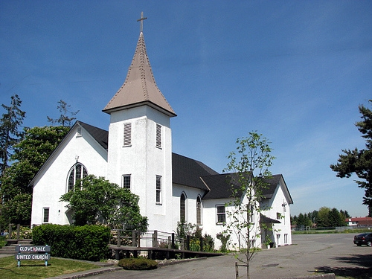
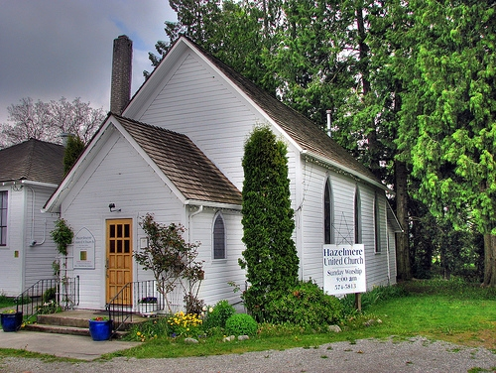
January  2015 |  | Cloverdale Pastoral Charge The United Church of Canada  17575 - 58A Avenue Surrey, B.C. V3S 1N1 / Telephone: 604-574-5813 / Fax: 604-574-5816  E-mail: cloverdalehazelmereuc@telus.net / Website: cloverdaleunitedchurch.ca  Worship & Sunday School: Hazelmere 8:45 a.m. / Cloverdale 10:30 a.m.  Minister: Rev. Lori Megley-Best / E-mail: lori.megley-best@telus.net
Sunday | Monday | Tuesday | Wednesday | Thursday | Friday | Saturday
  Annual General Meetings  (During Worship)  Cloverdale – Feb.15  Hazelmere – Feb. 15 |  |  | AA- 12noon / AA 7-9pm | 1    OA-730pm | 2  AA 12-1 / AA – 8-9pm | 3
  4 EPIPHANY  SUNDAY (Communion)  (HUC) Food Bank Sunday  Living Stones Church 1-5pm  Deadline-Easter Lily orders (CUC) | 5  AA-12 noon / NA 7-830  Pathfinders 6-8:30pm |   6  Friendship Unit  1:30pm at May Taylor’s  OA 7:30 / AA 7pm  Brownies 6-8pm | 7  Sunshine Unit  7:30pm at Lorrie Brown’s  AA- 12noon / AA 8-9pm   | 8    CUC Choir - 730pm  OA-730pm | 9  AA 12-1 / AA – 8-9pm | 10
  11 1st after Epiphany  Baptism of Jesus Sunday  Worship at Zion Park - 3pm  Gift Card Orders Due  Living Stones Church 1-5pm | 12  AA-12 noon / NA 7-830  Pathfinders 6-8:30pm | 13  OA 7:30 / AA 7pm  Brownies 6-8pm  Querin Dance 330-830pm | 14  AA- 12noon /  AA 7-8pm / AA 8-9pm | 15  CUC Choir - 730pm  OA-730pm | 16  Submissions Due for Annual Report  AA 12-1 / AA – 8-9pm | 17
18 2nd after Epiphany  Living Stones Church 1-5pm | 19  Note: Lori will be away  Jan 19 - 25  AA-12 noon / NA 7-830  Pathfinders 6-8:30p | 20  OA 7:30 / AA 7pm  Brownies 6-8pm | 21    Alpha Unit – 1pm  (CUC lounge)  AA- 12noon /  AA 7-8pm / AA 8-9pm | 22  CUC Choir - 730pm  OA-730pm  OA-730pm  OA-730pm | 23  AA 12-1 / AA – 8-9pm | 24  
25 3rd after Epiphany  (CUC) Celebration Box  Living Stones Church 1-5pm | 26  AA-12 noon / NA 7-830  Pathfinders 6-8:30p  AA-12 noon  Guides 6-8:30pm  31  Querin Dance 3-515 / Al-Anon 8pm |   27  Cloverdale Council – 7pm  OA 7:30 / AA 7pm  Brownies 6-8pm  Brownies 6-8pm | 28  AA- 12noon /  AA 7-8pm / AA 8-9pm | 29  CUC Choir - 730pm  OA-730pm | 30  AA 12-1 / AA – 8-9pm | 31

